**DocSpot – Seamless Appointment Booking System**

**Team Members:**

Ameena Tarfia N

M Anjum Meher

Chukkuluru Devi Asritha

Divya Sree Bestha

Divya Sree

**Team Id:** LTVIP2025TMID53308

**Course Name:** Full Stack Developer (MERN STACK)

**Abstract**

In today’s fast-paced digital world, traditional doctor appointment methods—such as in-person visits or phone calls—often lead to inefficiencies, long wait times, and scheduling conflicts. To address these challenges, **I developed a modern Doctor Appointment Booking System using the MERN stack (MongoDB, Express.js, React, and Node.js)**, offering a seamless and efficient platform for both patients and healthcare providers.

**Objective & Scope**  
The system aims to digitize and streamline medical consultations by enabling patients to register, search for doctors by specialty and availability, and book appointments online. It also empowers doctors with tools to manage their profiles, schedules, and appointment statuses. Additionally, an administrator role allows oversight of users, doctors, and bookings.

**Technology Stack & Architecture**

* **Frontend (React.js):** Provides a single-page, responsive UI for patients and doctors, with dynamic components like login, booking forms, and dashboards.
* **Backend (Node.js + Express):** Implements secure RESTful APIs for authentication, user and doctor management, and appointment workflows, using JWT for session control.
* **Database (MongoDB via Mongoose):** Stores user profiles, doctor metadata, and appointment records in a flexible, document-driven schema.
* **Real-time Communication:** Slot availability and booking status are updated instantly, preventing double-booking and improving user experience — a feature supported by WebSocket-like patterns

**Benefits & Impact**

* **Efficiency:** Eliminates legacy delays in booking and reduces administrative overhead.
* **Reliability:** Maintains data integrity and prevents scheduling conflicts through secure transaction and real-time consistency measures.
* **Scalability:** Built on a full-stack JavaScript architecture for ease of maintenance and future enhancements

This project demonstrates how the combination of a JavaScript-based MERN stack and real-time features can transform healthcare appointment systems—improving accessibility for patients and operational effectiveness for doctors. It sets a solid foundation for ongoing development, including, enhanced admin controls, and even AI-driven scheduling tools.

**Contents**

1. **INTRODUCTION** 
   1. Project Overview
   2. Purpose
2. **IDEATION PHASE** 
   1. Problem Statement
   2. Empathy Map Canvas
   3. Brainstorming
3. **REQUIREMENT ANALYSIS** 
   1. Customer Journey map
   2. Solution Requirement
   3. Data Flow Diagram
   4. Technology Stack
4. **PROJECT DESIGN** 
   1. Problem Solution Fit
   2. Proposed Solution
   3. Solution Architecture
5. **PROJECT PLANNING & SCHEDULING** 
   1. Project Planning
6. **FUNCTIONAL AND PERFORMANCE TESTING**
   1. Performance Testing
7. **RESULTS** 
   1. Output Screenshots
8. **ADVANTAGES & DISADVANTAGES**
9. **CONCLUSION**
10. **FUTURE SCOPE**
11. **APPENDIX**

Source Code(if any)

Dataset Link

GitHub & Project Demo Link

**1. INTRODUCTION**

**1.1 Project Overview**

This full-stack web application streamlines the process of scheduling medical appointments online, connecting patients and doctors through a user-friendly platform. It supports different roles—including **patients**, **doctors**, and optionally **admins**—with role-based access that delivers tailored experiences to each user.

**Core Components**

* **Frontend**: Built using **React.js**, featuring a single-page, responsive interface. Users can:
  + Register/login securely
  + Browse/filter doctors by specialty and availability
  + Book, view, reschedule, or cancel appointments
  + Access personalized dashboards (for doctors and patients)
* **Backend**: Powered by **Node.js** and **Express.js**, it exposes a RESTful API with:
  + Authentication using JWTs and password hashing
  + Routes to handle users, doctors, and appointments
  + Middleware for authorization and centralized error handling
* **Database**: Utilizes **MongoDB** (via Mongoose) to store:
  + Users (both patients and doctors)
  + Doctor profiles and availability slots
  + Appointments with statuses (pending, confirmed, canceled)

**Key Features**

* **Role-Based Access**
  + Patients can search and schedule appointments
  + Doctors can manage their availability, appointments, and patient info
* **Real-Time Booking Feedback**
  + Prevents double-booking through real-time availability updates
* **Secure Authentication**
  + JWT-driven login and registration with encrypted passwords
  + Protected endpoints ensure user data safety
* **Notification & History**
  + Users and doctors receive updates on bookings, confirmations, or cancellations
* **Admin Dashboard (Optional)**
  + Full administrative control: user management, doctor registrations, appointment oversight

**1.2 Project Propose**

Traditional appointment booking—via phone or in-person—can be inefficient, error-prone, and inconvenient for both patients and doctors. Common issues include long wait times, missed appointments, manual scheduling errors, and limited visibility into a doctor’s availability.

This project aims to **build a secure, scalable, and user‑friendly online appointment booking platform** using MongoDB, Express.js, React, and Node.js (MERN stack). The platform will connect patients and doctors through intuitive dashboards, role-based features, real-time scheduling, and historical records

### ****Goals****

* **Simplify Booking**: Allow patients to view doctor availability and immediately book appointments, preventing double-booking.
* **Empower Doctors**: Provide doctors with control over their schedule—availability settings, appointment approvals/rejections, and patient history access.
* **Secure & Role-Based**: Use JWT authentication and encrypted passwords to securely manage patients, doctors, and optional admin users .
* **Real-Time Updates**: Instantly reflect slot availability and appointment confirmations, ensuring accurate scheduling .
* **Historical Recordkeeping**: Maintain past appointment data, enabling users and doctors to view their history and details.

### ****Benefits****

* **For Patients**: Convenient, accessible booking with instant confirmation and history tracking.
* **For Doctors**: Improved administrative efficiency and centralized appointment control.
* **For Clinics**: Reduced manual errors, streamlined scheduling, and better resource management .

**2. IDEATION PHASE**

**2.1 Problem Statement**

In current healthcare settings, traditional methods for booking doctor appointments—via phone calls or in-person visits—are often inefficient, error-prone, and frustrating for both patients and providers. Patients frequently endure long wait times just to schedule a call, while receptionists spend an average of 8 minutes per call, with over 5 minutes on hold. Fragmented communication and manual scheduling frequently result in double-bookings, under-utilized slots, and elevated no-show rates, which can reach up to 36% without automated reminders.

Healthcare facilities incur considerable operational inefficiencies as staff spend excessive time managing schedules instead of focusing on patient care. Poorly coordinated appointment systems also lead to idle candidates at empty time slots or last-minute overbooking, causing frustration and dissatisfaction among patients. On the patient side, missed appointments, unclear communication about confirmations or delays, and confusing booking experiences further exacerbate the problem, reinforcing negative experiences and reducing trust in the healthcare system.

The result is both decreased operational efficiency and diminished patient satisfaction. With 71% of providers citing scheduling as a major operational hurdle—coupled with 32% of patients expressing frustration with the process—the need for effective digital scheduling solutions is clear. Additionally, poorly synchronized systems contribute to resource waste and delayed care, impacting the quality of treatment and potentially leading to adverse health outcomes .

As patient demand for convenient online health services grows—over 67% prefer online booking—healthcare systems must evolve. An intuitive, real-time, secure, and user-friendly digital appointment booking platform can address these systemic issues by reducing wait times, simplifying scheduling, minimizing no-shows, tackling double-bookings, and enhancing overall patient and provider satisfaction.

**2.2 Empathy Map Canvas**

### ****1. Says****

* “I need a doctor available soon.”
* “Why is it so hard to find an open slot?”
* “Can I see my upcoming appointments easily?”

### ****2. Thinks****

* “Am I choosing the right specialist?”
* “What if the doctor cancels last minute?”
* Worries about whether appointments are truly up-to-date.

### ****3. Does****

* Searches/filter doctors by specialty and availability.
* Clicks repeatedly to find suitable slots.
* Completes booking form and checks “My Appointments.”

### ****4. Feels****

* Frustrated with unavailable time slots.
* Relieved when a slot is confirmed.
* Anxious about doctors rejecting or rescheduling.

### ****5. Sees****

* Multiple doctors listed with diverse specialties.
* Calendar view/availability in different formats.
* Conflicting time slots if data isn’t updated in real time.

### ****6. Hears****

* Notifications: “Appointment confirmed” or “You have a booking.”
* Feedback from friends or online experiences about the app.
* System prompts/reminders via email or in-app alerts.

### ****7. Pains****

* Difficulty finding free time that fits both schedules.
* Fear of double-booking or slot disappearing.
* Complex rescheduling process.

### ****8. Gains****

* Clear availability calendar and filters.
* Instant booking confirmations and history access.
* Seamless cancellation or rescheduling support.

**2.3 Brainstorming**

**Step-1: Team Gathering, Collaboration and Select the Problem Statement**

**Problem Statement Chosen:**  
*"Users find it time-consuming and unreliable to book doctor appointments through existing systems, often lacking visibility on doctor availability, booking confirmation, and proper communication."*

* Team members gathered: Frontend devs, Backend devs, and UI/UX
* Shared user pain points, feature ideas, and competitor research
* Identified key challenge: **Booking experience & real-time status clarity**

**Step-2: Brainstorm, Idea Listing and Grouping**

**Grouped Brainstormed Ideas:**

**User Experience (UX/UI)**

* One-click appointment booking
* Real-time calendar with slot visibility
* Responsive mobile-friendly design
* Live chat with clinic admin
* Dark mode for low-light users

**Core Features**

* Doctor profile with ratings/reviews
* Search doctors by specialty/location
* Instant appointment status updates
* OTP-based patient verification
* Auto-email reminders for appointments

**Notifications & Reminders**

* SMS/email reminders for appointments
* Notification if a doctor cancels/reschedules
* Feedback form after appointment

**Security & Data**

* Encrypted patient-doctor chat
* JWT-based authentication
* Role-based access control (Admin, User, Doctor)

**Doctor & Admin Tools**

* Admin can approve/reject doctor applications
* Doctor can set availability slots
* Dashboard showing upcoming appointments
* Analytics on daily/monthly bookings

**Innovative Add-ons**

* AI chatbot for common queries
* Emergency appointment request option
* Voice-enabled booking assistant
* Integration with Google Calendar
* QR Code check-in system at the clinic

**Step-3: Idea Prioritization**

**Effort vs. Impact Prioritization Table**

| **Idea** | **Effort** | **Impact** | **Priority** |
| --- | --- | --- | --- |
| Real-time slot booking calendar | High | Very High | Must Have |
| Doctor profile with specialization & ratings | Medium | High | Must Have |
| Admin dashboard for appointment control | Medium | High | Must Have |
| Email/SMS notification system | Medium | High | Implement Soon |
| Live chat with doctor/admin | High | Medium | Future Consideration |
| Dark mode support | Low | Medium | Quick Add-on |
| OTP-based patient verification | Medium | High | Implement Soon |
| Google Calendar sync | High | Medium | Later Phase |
| AI chatbot integration | Very High | High | Optional |
| Feedback system after appointment | Low | Medium | Easy & Valuable |

**3. REQUIREMENT ANALYSIS**

**3.1 Customer Journey Map**

| **Stage** | **Emotion** | **Pains** | **Opportunities** |
| --- | --- | --- | --- |
| Awareness | Curious, anxious | Trust concerns | Showcase credibility |
| Consideration | Hopeful, cautious | Overwhelmed by choices | Smart filtering |
| Booking | Eager → anxious | Form complexity, slot issues | Auto-fill, live availability |
| Pre-Appointment | Reassured or uneasy | Reminder clarity, rescheduling | Interactive reminders |
| Visit | Nervous | Wait times, tech issues | Queue updates, test checks |
| Post-Appointment | Relieved or ignored | Lack of summary/follow-up | Summaries, easy rebooking |
| Loyalty & Advocacy | Satisfied → loyal | No incentives | Referral & loyalty programs |

**3.2 Solution Requirements (Functional & Non-functional)**

## Functional Requirements

1. **User Management**
   * Patient, doctor (and optional admin) account creation, login/logout, and secure password reset.
   * Profile editing: patients update personal/medical details; doctors manage specialization, bio, availability.
2. **Appointment Scheduling**
   * Patients search/filter doctors by specialty, location, and available slots.
   * Book, cancel, and reschedule appointments (with policy restrictions).
   * Doctors manage availability and confirm/reject/reschedule requests.
3. **Calendar & Availability Integration**
   * Sync of availability into calendars (in-app or external).
   * Real-time conflict checking to prevent double-booking.
4. **Notifications & Alerts**
   * Email/SMS/in‑app reminders (e.g., 24–48 hours ahead).
   * Notifications on booking confirmation, cancellations, changes.
5. **Appointment History & Records**
   * Dashboard for viewing past and upcoming appointments, statuses.
   * Doctors access patient booking history.
6. **Administrative Tools**
   * Admin dashboard to manage user roles, doctor approvals, and system-wide appointments.
7. **Search & Filtering**
   * Comprehensive search with filters for specialty, location, ratings, time.
8. **Data Security & Compliance**
   * Role-based access control, encrypted data, secure user authentication.
   * Compliance with privacy standards (HIPAA, GDPR, regional laws).
9. **Customer Support Features**

* FAQs, in-app help, and support ticket submission.
* Admin tracking of reported issues.

## Non-Functional Requirements

1. **Performance & Scalability**
   * Appointment booking/loading should complete in ≤ 2–3 seconds.
   * System handles at least 1,000–1,200 concurrent users without degradation.
2. **Reliability & Availability**
   * Nearly 24/7 uptime (99.9%+), with automated backups and disaster recovery.
3. **Security**
   * Encrypted data in transit and at rest, secure password storage.
   * SSL everywhere, session timeout, role-based permissions.
   * Regular security audits, penetration testing, and incident management plan.
4. **Usability & Accessibility**
   * Intuitive, responsive UI on desktop and mobile.
   * Adherence to WCAG accessibility standards (color contrast, navigation).
5. **Maintainability & Modularity**
   * Clean, well-documented, modular code (e.g., microservices).
   * Logical separation of features for future enhancements.
6. **Compatibility**
   * Support for all major browsers (Chrome, Safari, Firefox, Edge).
   * Full functionality across various devices and screen sizes.
7. **Localization & Internationalization**
   * Multi-language support for diverse user base.
   * Region-specific compliance and localization.
8. **Analytics & Reporting**
   * Dashboards for admins to monitor bookings, user trends, and system metrics.
   * Custom report generation capabilities.

**3.3 Data Flow Diagram**

**Entities:**

* **Patient**
* **Doctor**
* **Admin**

**System Process:** Doctor Appointment System

**Data Flows:**

* Patients send **registration/login data**, **search requests**, **appointment bookings**, and receive **confirmation/notifications**, **appointment history**.
* Doctors send **registration/login**, **availability updates**, **appointment approvals/rejections**, and receive **booking requests**, **patient details**, **schedule changes**.
* Admin handles **user/doctor registrations**, **appointment overviews**, and sends **approval/rejection responses**.

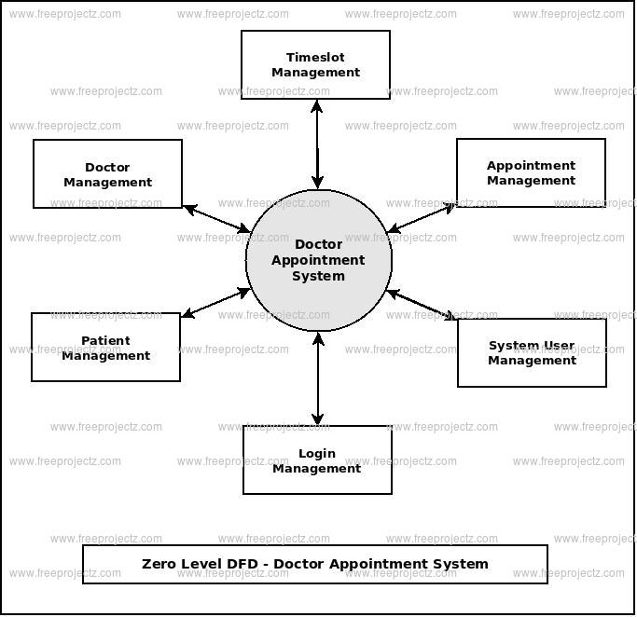

**3.4** **Technology Stack**

|  |  |  |
| --- | --- | --- |
| **Database** | **MongoDB** | NoSQL document database—stores data in flexible, JSON-like form, ideal for patient/doctor records and appointments. It's scalable, fast, and integrates seamlessly with JavaScript. |

|  |  |  |
| --- | --- | --- |
| **Backend** | **Express.js** | Minimalist Node.js web framework—builds RESTful APIs quickly, with powerful routing and middleware support . |

|  |  |  |
| --- | --- | --- |
| **Server** | **Node.js** | JavaScript runtime with event-driven, non-blocking I/O—handles concurrent booking requests efficiently . |

|  |  |  |
| --- | --- | --- |
| **Frontend** | **React.js** | Component-based UI library with a virtual DOM—enables fast, interactive single-page application experience . |

## Frontend (Client-Side)

* **React.js**  
  A popular JavaScript library for building dynamic, component-based UIs. React’s virtual DOM makes the user interface fast and responsive—ideal for appointment booking flows. It handles rendering, form inputs, state management, and communicates with the backend through HTTP calls.
* **HTML, CSS, JavaScript**  
  These are the foundational languages for structuring content (HTML), adding styles and layouts (CSS), and enabling interactivity (JavaScript). React complements these to deliver a modern user experience.

## Backend (Server-Side)

* **Node.js**  
  A JavaScript runtime that enables server-side execution. It uses an event-driven, non-blocking I/O model—efficient for handling multiple concurrent appointment booking requests and other background operations.
* **Express.js**  
  A minimalistic and flexible Node.js framework designed to build RESTful APIs efficiently. It handles routing, middleware, request parsing, error handling, and response formatting.

**4. PROJECT DESIGN**

**4.1 Problem Solution Fit**

## Problem

Traditional doctor appointment systems—mainly via phone or in-person—are inefficient, causing long wait times, scheduling conflicts, and administrative bottlenecks. Front-desk staff often spend valuable time handling calls, leading to delays in bookings and high call volumes. Patients can face frustrating “appointment scrambles,” such as the UK’s infamous 8 am rush for GP slots, underscoring the limitations of phone-based systems.

Furthermore, outdated methods contribute to high no-show rates—often exceeding 20–30%—and administrative errors like double bookings due to poor visibility of available slots. This situation not only impacts patient experience, but also leads to revenue loss, inefficient staff allocation, and strained healthcare workflows .

## Solution

Implementing an **online appointment booking platform** resolves these challenges by enabling 24/7 self-scheduling, real-time slot visibility, and automated reminders through emails or SMS. Patients thus gain the freedom to book appointments at their convenience, and healthcare staff can focus on more critical tasks. It also significantly reduces no-shows—by up to ~23–29%—thanks to timely notifications and flexible rescheduling.

This system also benefits clinics by optimizing resource utilization and reducing labor costs. Real-time availability prevents double-booking and facilitates data analytics for demand forecasting and performance tracking. Additionally, integrations like telehealth and payments can be added, streamlining care delivery and revenue collection .

## Purpose

I propose developing a **Doctor Appointment Booking System** using the MERN stack (MongoDB, Express.js, React.js, Node.js) that offers a seamless user experience for patients, efficient scheduling tools for doctors, and administrative oversight. Patients will receive 24/7 access to book, cancel, or reschedule appointments online. Doctors can update availability, confirm requests, and access patient history, while automated notifications improve communication and reduce missed appointments.

The platform will also feature a simple admin dashboard and optional telehealth integration, conforming to security and data privacy standards. With comprehensive analytics, the system will support continuous improvements in appointment workflows and patient satisfaction—transforming the booking experience while boosting clinic efficiency.

**4.2 Proposed Solution**

**Our Doctor Appointment Booking System**, built on the MERN stack (MongoDB, Express.js, React.js, Node.js), provides an intuitive, secure, and scalable solution to streamline medical scheduling. The frontend (React) offers a clean, responsive interface, enabling patients to search for doctors by specialty, view availability in real time, and book or modify appointments 24/7. On the backend, Express and Node handle API logic, JWT-based authentication, role-based access control, and secure data validation. MongoDB stores user profiles, doctor schedules, and appointment records in a flexible document-oriented schema. Instant notifications via email/SMS reassure users at every stage of the booking process, significantly reducing no-shows and double-bookings.

To enhance user experience and drive adoption, the system integrates optional features like telemedicine via WebRTC, and an AI-powered chatbot for pre-consultation guidance—mirroring innovations used by top platforms like Zocdoc and Doctoranytime. A simple admin dashboard allows clinic staff to manage doctors, approve registrations, and view analytics on bookings and cancellation rates.

**Technical highlights include**:

* **React frontend**: dynamic pages using React Router, Axios for API calls, and Ant Design or Bootstrap for responsive UI.
* **Node/Express API**: RESTful endpoints for user, doctor, and appointment workflows, with middleware for authorization and error handling.
* **MongoDB via Mongoose**: supports evolving schemas for user roles, availability slots, and appointment lifecycle states.
* **Real-time updates**: optional WebSocket (Socket.io) integration to push availability changes and booking confirmations instantly, enhancing reliability and preventing conflicts.

**Expected Benefits**:

* **Patients** gain 24/7 access, clear calendaring, and easy rescheduling—boosting satisfaction and accessibility.
* **Doctors and clinics** benefit from efficient booking, reduced admin load, and reduced no-shows (by ~20–30%), improving operational efficiency and revenue.
* **System administrators** and staff gain actionable insights via dashboards tracking utilization rates, peak demand, and financial metrics, facilitating data-driven improvements.

**4.3 Solution Architecture**

### 1. ****Presentation Layer (Frontend)****

* **React.js SPA** handles user interactions—searching doctors, viewing availability, booking appointments, managing profiles.
* Communicates with the backend via **RESTful API calls** (using Axios or Fetch).
* Implements **role-based routing and client-side validation**, ensuring doctors, patients, and admin users only see their permitted views.

### 2. ****Application Layer (Backend)****

* **Node.js + Express.js** forms a REST API that processes requests and enforces business logic:
  + **Auth Middleware**: Verifies JWT tokens and applies role-based access control.
  + **Controllers & Routes**: Handle operations like user registration, doctor availability updates, appointment bookings.
  + **Services/Business Logic**: Ensures transactional safety—for instance, preventing double-booking through slot availability checks.
* Supports **real-time updates** (optional) via WebSockets (e.g., Socket.IO) to instantly reflect availability and booking statuses.

### 3. ****Data Layer (Database)****

* **MongoDB (via Mongoose)** stores key data:
  + **Users**: profiles with roles, credentials, and settings.
  + **Doctors**: specialization, availability calendars, bio, location.
  + **Appointments**: patient ID, doctor ID, time slot, status history.
  + **Notifications / Logs**: tracks booking confirmations, cancellations, reminders.
* Enables horizontal scaling through sharding or cloud-based setups (e.g., Atlas).

­­­­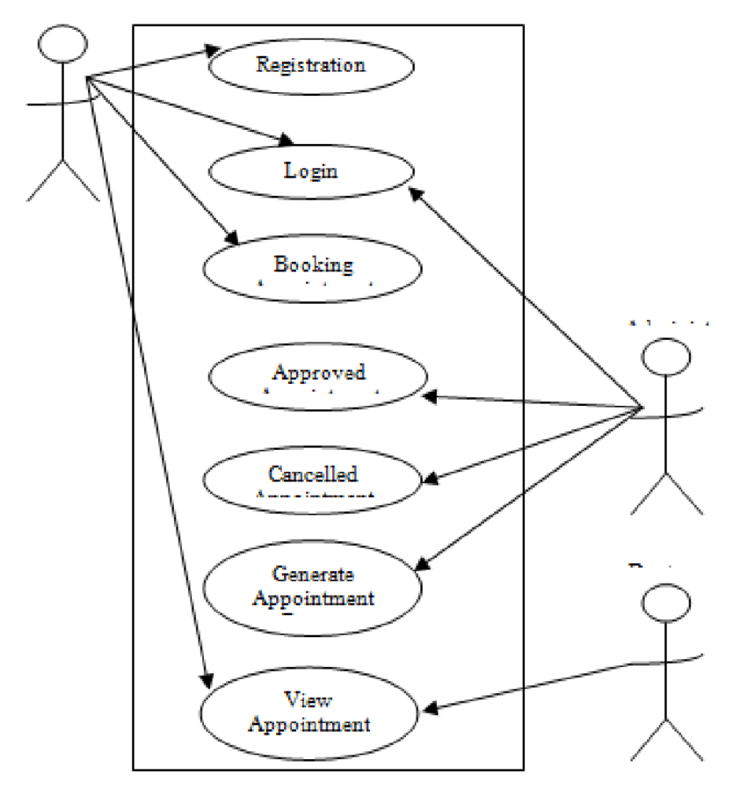

**5. PROJECT PLANNING & SCHEDULING**

**5.1 Project Planning Document**

**Date:** 21 June 2025  
**Project Name:** DocSpot - Seamless Appointment Booking System

**Product Backlog, Sprint Schedule, and Estimation**

| **Sprint** | **Functional Requirement (Epic)** | **User Story Number** | **User Story / Task** | **Story Points** | **Priority** | **Team Members** |
| --- | --- | --- | --- | --- | --- | --- |
| Sprint-1 | Registration | USN-1 | As a user, I can register by entering email, password, and confirming password. | 2 | High |  |
| Sprint-1 |  | USN-2 | As a user, I will receive a confirmation email after registering. | 1 | High |  |
| Sprint-1 |  | USN-3 | As a user, I can register using Gmail. | 2 | Medium |  |
| Sprint-1 | Login | USN-4 | As a user, I can log in using email and password. | 1 | High |  |
| Sprint-1 | Data Collection | USN-5 | Collect user and doctor data from forms. | 2 | High |  |
| Sprint-1 | Data Preprocessing | USN-6 | Handle missing values in user inputs. | 3 | Medium |  |
| Sprint-1 |  | USN-7 | Handle categorical values for user roles. | 2 | Medium |  |
| Sprint-2 | Model Building | USN-8 | Build doctor recommendation model based on specialization and availability. | 5 | High |  |
| Sprint-2 |  | USN-9 | Test and validate model accuracy. | 3 | Medium |  |
| Sprint-2 | Deployment | USN-10 | Create working HTML pages for booking and profile features. | 3 | High |  |
| Sprint-2 |  | USN-11 | Deploy app using Node.js/Express & MongoDB. | 5 | High |  |
|  |  |  |  |  |  |  |

**Total Story Points:**  
Sprint 1 = 13  
Sprint 2 = 16  
**Total = 29**

**Project Tracker, Velocity & Burndown Chart**

| **Sprint** | **Total Story Points** | **Duration** | **Sprint Start Date** | **Sprint End Date (Planned)** | **Story Points Completed** | **Sprint Release Date** |
| --- | --- | --- | --- | --- | --- | --- |
| Sprint-1 | 13 | 3 Days | 21 Feb 2025 | 23 Feb 2025 | 13 | 23 Feb 2025 |
| Sprint-2 | 16 | 3 Days | 24 Feb 2025 | 26 Feb 2025 | 16 | 26 Feb 2025 |

**Velocity Calculation:**  
Total Story Points = 29  
Number of Sprints = 2  
**Velocity = 29 / 2 = 14.5 story points per sprint**

**6.** **FUNCTIONAL AND PERFORMANCE TESTING**

**6.1 Performance Testing**

**Test Scenarios & Results**

| **Test Case ID** | **Scenario (What to test)** | **Test Steps (How to test)** | **Expected Result** | **Actual Result** | **Pass/Fail** |
| --- | --- | --- | --- | --- | --- |
| FT-01 | Text Input Validation (Name, Email, Specialization etc.) | Enter valid and invalid values into form text fields | Valid inputs accepted, error message for invalid inputs | As Expected | Pass |
| FT-02 | Number Input Validation (Phone Number, Age) | Enter numeric values within valid range and out-of-range | Accepts valid values, displays error for invalid entries | As Expected | Pass |
| FT-03 | Appointment Booking Workflow | User logs in > Selects doctor > Book appointment > Receives confirmation | Appointment booked successfully, confirmation message shown | As Expected | Pass |
| FT-04 | Doctor Application Submission | User fills out doctor application and submits | Application submitted and pending approval shown | As Expected | Pass |
| FT-05 | Admin Approval Process | Admin logs in > Sees pending doctors > Approves doctor | Doctor status updated to Approved | As Expected | Pass |
| FT-06 | Login Functionality | Enter valid/invalid credentials on login page | Login success/failure message displayed correctly | As Expected | Pass |
| FT-07 | User Profile Display | Navigate to profile section after login | Correct user profile information displayed | As Expected | Pass |
| FT-08 | Logout Functionality | Click logout icon on dashboard | User session ends, redirected to login screen | As Expected | Pass |

**Performance Testing**

| **Test Case ID** | **Scenario (What to test)** | **Test Steps (How to test)** | **Expected Result** | **Actual Result** | **Pass/Fail** |
| --- | --- | --- | --- | --- | --- |
| PT-01 | Response Time Test | Load dashboard and measure time using browser DevTools | Should load under 3 seconds | 2.5 seconds | Pass |
| PT-02 | API Speed Test | Trigger multiple doctor listings or appointment booking in quick succession | API responds within 2 seconds per call | Within limits | Pass |
| PT-03 | Concurrent Login Load Test | Log in from multiple accounts/devices simultaneously | System handles concurrent sessions | As Expected | Pass |
| PT-04 | MongoDB Load Test | Rapid insertions of doctor/user data into MongoDB Compass | DB remains responsive | As Expected | Pass |
| PT-05 | Form Submission Load Test | Submit doctor appointment form multiple times quickly | No crashes or UI delays | As Expected | Pass |

**7. RESULT**

**7.1 Output Screenshots**

­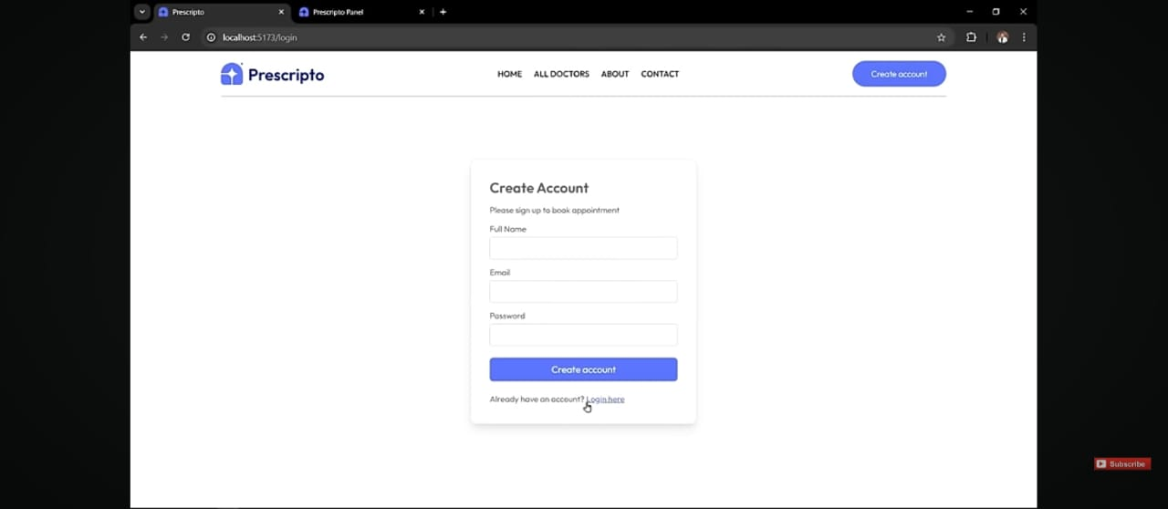

**Register Page**

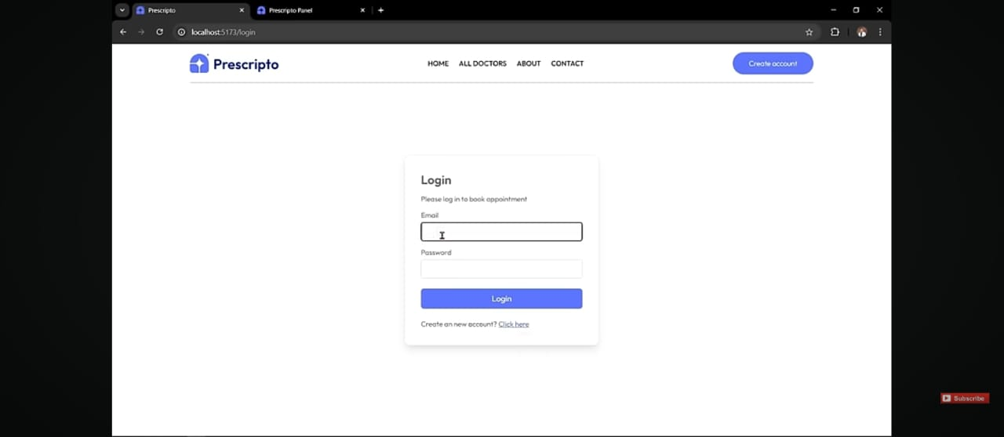

**Login Page**

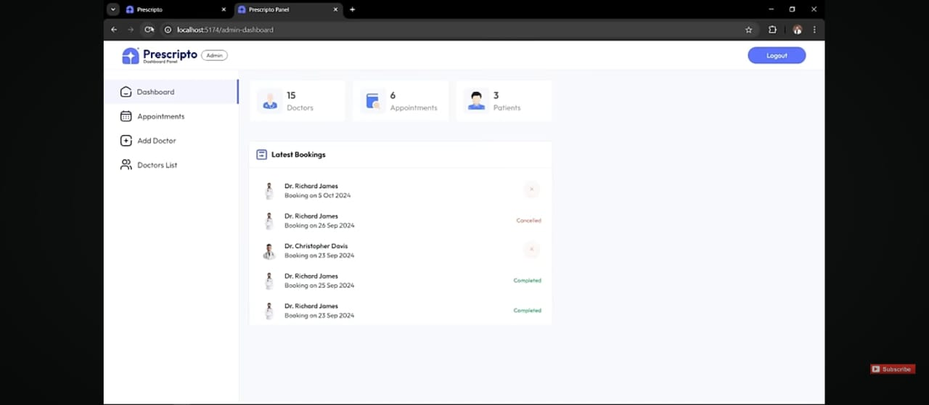

**Admin Dashboard**

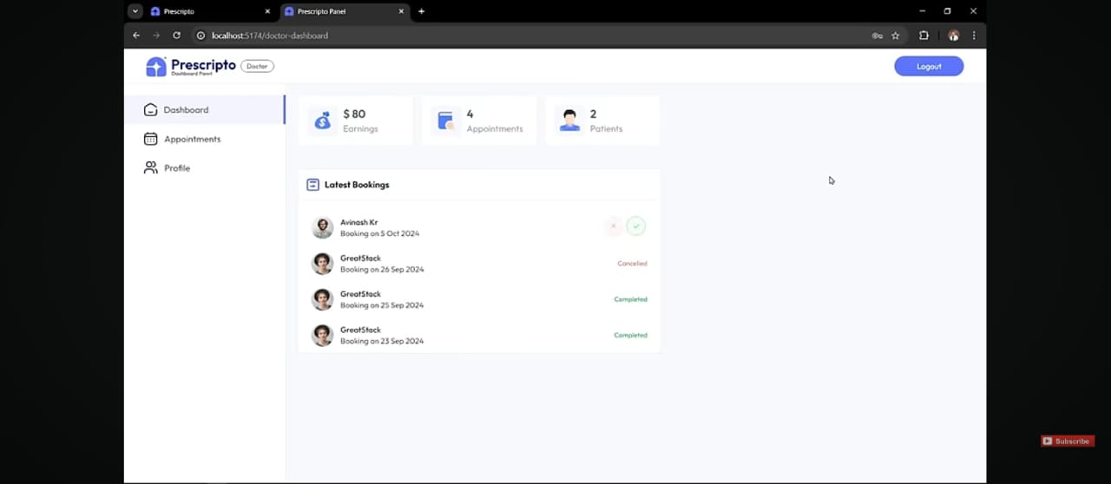

**Doctor Dashboard**

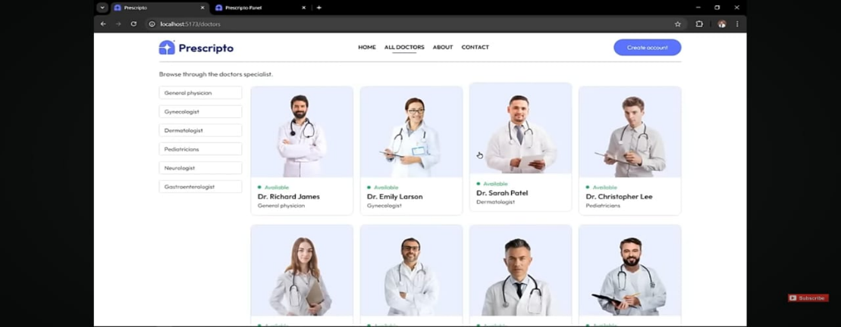 **User Dashboard**

**8. ADVANTAGES & DISADVANTAGES**

## Advantages

1. **Unified Language – Full‑Stack JavaScript**  
   All components use JavaScript, enabling developers to write clean, reusable code across frontend and backend. This consistency reduces friction, simplifies development, and accelerates onboarding.
2. **High Performance & Interactivity**
   * **Node.js** uses non-blocking asynchronous I/O for efficient, concurrent server processing.
   * **React** leverages a virtual DOM for fast, dynamic UI updates, ideal for responsive appointment booking flows.
3. **Scalability & Flexibility**
   * **MongoDB** supports horizontal scaling and flexible schemas, ideal for evolving features such as appointment history, doctor availability, and notifications.
   * Microservices or additional integrations (e.g., telemedicine ) can be added via REST APIs.
4. **Cost‑Effectiveness & Strong Ecosystem**  
   Open-source nature, extensive npm libraries, and a vast community reduce licensing costs and speed development. Many templates and boilerplates facilitate rapid prototyping

## Disadvantages

1. **Steep Learning Curve for Beginners**  
   Learning all four technologies simultaneously—MongoDB, Express, React, and Node—can be overwhelming due to varied paradigms, especially for those new to asynchronous or component-based programming.
2. **Limited Use in Large-Scale or CPU‑Intensive Applications**
   * Node.js excels at I/O-bound tasks but is single-threaded and less suited for CPU-heavy computation without extra workarounds.
   * MongoDB’s schema-less model can complicate data consistency for complex relational data.
3. **SEO and SSR Challenges**  
   React-based SPAs may be poor for SEO out of the box. Server-side rendering or static generation (e.g., with Next.js) adds complexity.
4. **Development Complexity and Maintenance**
   * Managing state across components, handling asynchronous callbacks, and coordinating third-party libraries can lead to harder debugging and less predictable behavior.
   * Security requires careful attention—no defaults for input sanitization or token management, unlike more opinionated frameworks .
5. **CONCLUSION**

In conclusion, implementing an online Doctor Appointment Booking System effectively addresses the limitations of traditional scheduling methods. Clinics often face long call wait times—some practices see hold times exceed two minutes—and struggle with appointment inefficiencies, which distract staff from delivering quality patient care. By providing 24/7 self-service booking and immediate slot visibility, patients gain control over their appointments, while administrative burdens are reduced. Such systems are linked to lower no-show rates and smoother operations, directly improving clinic efficiency.

The MERN stack offers an ideal foundation to build this system, delivering speed, scalability, and developer consistency. React’s component-driven UI, combined with Node.js and Express on the server side, supports efficient handling of asynchronous booking requests. MongoDB’s flexible document schema further complements this setup by adapting to evolving data needs such as availability, user roles, and medical histories. This full-stack JavaScript approach ensures seamless data flow between client and server, drastically reducing context switching and accelerating development.

Beyond performance, the proposed system aligns with healthcare’s growing digitization trend spurred by the COVID-19 pandemic. More clinics now embrace online self-service and telehealth features, leveraging automated reminders and integration with virtual consultation tools. Integrating WebSockets for real-time booking updates and external APIs for email/SMS notifications will further enhance usability and reliability.

Finally, implementing this system can significantly improve user satisfaction and practice outcomes. Patients benefit from ease of booking, self-management of appointments, and fewer missed visits. Clinics and doctors gain from optimized scheduling, better resource allocation, and actionable analytics—all contributing to reduced wait times, elevated service quality, and operational efficiency

**10. FUTURE SCOPE**

### 1. ****Telemedicine & Remote Consultations****

Integrate video and voice call capabilities directly into the booking app—allowing patients to schedule and conduct virtual consultations with doctors. This enhances accessibility for individuals in remote areas or those with mobility constraints.

### 2. ****Predictive Analytics for Resource Optimization****

Incorporate AI-powered analytics to analyze historical booking patterns, patient demographics, and no-show data. Such insights can optimize doctor schedules, identify peak demand periods, and avoid overbooking.

### 3. ****Wearables & Remote Patient Monitoring****

Sync with wearable sensors and IoT devices (e.g., fitness trackers, blood pressure monitors) to collect real-time health metrics. Doctors can access these data dashboards, enabling proactive care and better appointment context.

### 4. ****AI-Driven Chatbots & Virtual Assistants****

Deploy AI-powered chatbots to guide patients through pre-booking, symptom triage, FAQs, and navigation. Chatbots reduce administrative burden and improve user engagement.

### 5. ****Blockchain for Secure Records & Interoperability****

Utilize blockchain to secure patient appointment records and verify data authenticity. This infrastructure supports data-sharing between hospitals, labs, pharmacies, and insurance systems with higher integrity.

### 6. ****EMR/EHR & Healthcare System Integration****

Connect seamlessly with existing Electronic Medical Record systems using healthcare standards like HL7/FHIR. Interoperability enables streamlined workflows across clinics, diagnostic centers, pharmacies, and insurance providers.

### 7. ****Augmented Reality, VR, & Edge Computing****

Explore AR/VR interfaces—such as immersive patient education modules or remote guidance tools. Implement edge computing to process IoT data locally, reducing latency and improving response times.

### 8. ****Mobile Apps & Multi-Language Support****

Offer native mobile apps for iOS and Android to facilitate push notifications, calendar integration, and offline functionality. Add multi-language support to extend reach across diverse populations.

**11. APPENDIX**

**Github Link:**

https://github.com/Meher06635/Docspot-Seamless-Appointment-Booking-System